

**Opening Remarks for Panel on the Macro-Economy and Quantitative Easing**

Speech given by

Tim Besley, Member of the Monetary Policy Committee, Bank of England

At the London School of Economics 2 July 2009

I would like to thank Jake Horwood, Neil Meads and Paolo Surico for assistance in preparing these remarks. I am also grateful for helpful comments from other colleagues. The views expressed are my own and do not necessarily reflect those of the Bank of England or other members of the Monetary Policy Committee.

1

All speeches are available online at [www.bankofengland.co.uk/publications/Pages/speeches/default.aspx](http://www.bankofengland.co.uk/publications/Pages/speeches/default.aspx)

Recent monetary policy in the U.K. has been far from “business as usual”. In response to the dramatic events following the collapse of Lehman brothers, the MPC cut interest rates to 0.5% and initiated a program of asset purchases financed by the creation central bank reserves, something which is popularly known as *quantitative easing,* hereafter QE. The MPC has so far set a target for asset purchases of £125 billion which will have been completed in the next month or so. To date £99.1 billion of assets have been purchased with £96.4bn being Gilts and £2.8bn being private sector assets of which £1.95 billion is commercial paper and £0.78 billion is in corporate bonds.1 Progress towards the MPC’s objective is given in Chart 1.

In my opening remarks for this session, I plan to discuss three main issues. First, it is useful to review the motivation for QE. Second, I will tie this to a discussion of the transmission mechanism of monetary policy and the role of financial frictions in affecting this. This will allow me a brief reflection on the dominant mode of thinking about that mechanism in academic and policy circles over the past decade or so.

Third, I will use this discussion to reflect on the future and the implications for a return to more normal policy as the economy recovers.

So I begin with the motivation for QE as monetary policy. Here, I want to emphasise that QE is the natural way to conduct monetary policy when nominal interest rates hit their effective lower bound. Indeed, in many respects it is a natural extension of standard open market operations that are used to implement Bank Rate.

Standard theories say that a Central Bank can stimulate the growth of nominal demand by increasing base money which then increases broad money and ultimately feeds into spending decisions by households and businesses. In the canonical example, this policy is conducted by purchases of safe Treasury Bills so that the Bank does not face concerns about managing default risk on the assets that it purchases.

Let me make one observation on this simple story that I will pick up later. The stylized model of QE does not need to make any direct appeal to the role of financial frictions in affecting its impact. However, you will be aware that many accounts of

1 Correct as of COB 25/6/2009

the way that the increased liquidity injected affects the real economy have emphasised imperfect substitutability of assets – something which really only makes sense when such frictions are present. This was the centre piece of the analysis of the transmission mechanism by Brunner and Meltzler. But the economics 101 version of QE could be told more simply via a real balance effect – seeing the impact through increasing nominal wealth where the role of the financial sector (imperfect or otherwise) could be kept firmly in the background.

There are two distinct objectives underpinning the QE strategy being pursued at the present time.

The first corresponds to the standard argument for expansionary monetary policy that corresponds to the stylized account given above. This aim of QE is to reverse the fall in the growth rate of nominal GDP and to avoid the threat of a period of below target inflation, or even deflation.

It is difficult to assess whether QE is working in this regard given the usual long and variable lags in the transmission process. Moreover, it is extremely difficult to know the counterfactual path of money growth and nominal GDP had the MPC not introduced its program of asset purchases. Thus, we will not know for sure whether QE has been directly effective in supporting nominal demand growth for some time and a definitive assessment right now would certainly be premature.

The second purpose of asset purchases is to improve conditions in some private asset markets, particularly improving market liquidity. Some have used the term Credit Easing rather than Quantitative Easing to describe this. In part, this is because such operations could arguably be just effective if they were financed by issuance of short term securities such as Treasury Bills. There is some evidence that funding conditions in corporate bond markets have improved and there is some new issuance. Given difficulties with obtaining bank finance, directly placed debt is a potentially more attractive source of finance for many businesses at present, assuming that they are able to take advantage of such funding opportunities. But directly placed debt is generally only viable for larger businesses.

Given the size of the QE program, it was inevitable that a program of QE would end up focusing on Gilt purchases given the size of the market for Corporate Bonds and Commercial Paper. Focusing on Gilt purchases in the middle of the yield curve is partly an effort to try to inject money into the non-Bank sector to avoid the possibility that such reserves would simply be hoarded in Bank accounts. In line with the Brunner-Meltzler logic, we might also hope that reductions in Gilt yields will encourage holding of relatively more illiquid assets.

So while QE is primarily intended to support the growth of nominal demand, there are certainly potential benefits in easing financial frictions.

This brings me to my second topic.

Behind the recent experience lies the fact that monetary policy is now being conducted in the context of ongoing difficulties in a number of financial markets. This would be an issue even if policy were being conducted by raising and lowering Bank Rate in the conventional way. If I look back over the entire three year period on which I have been on the MPC, financial frictions (or lack thereof) have been absolutely central to understanding monetary policy effectiveness. This is important since the standard, and dominant, modelling approach to the transmission mechanism puts very little weight on these.

Prior to August 2007, financial markets were buoyant with leverage growing and balance sheets of Banks expanding. Risk premia became compressed as illustrated in Chart 2. Arguably, this meant that small increases in Bank Rate were having relatively little impact on real activity. Most real asset prices are influenced by long- term real interest rates which became unhinged from short-term rates, arguably set more by global developments and financial flows. Frictions in financial markets seemed to be minimal with ready access to credit on easy terms for many borrowers whether in the corporate or household sector. This world was, as we now understand, not sustainable. But it remains a real question how far movements in Bank Rate could and should have been used to deal with these issues. Recognizing this, the current debate has now rightly opened up on what other instruments make sense and what institutional arrangements are needed to ensure that these are used appropriately.

These are important issues, but I do not propose to enter this debate today. However, they are central to this conference.

Following the onset of the credit crunch, we have entered a world where frictions in financial markets have re-asserted themselves with a vengeance. This is visible in the well-known charts of a variety of spreads such as those illustrated in Chart 3.

Conceptually, these spreads comprise compensation for default risk and liquidity risk as well as reflecting the market-power of lenders. It remains difficult to provide a convincing decomposition of the spread into these components.

But spreads do not tell the full story. Unlike more standard markets, it is well-known that the threat of default creates the possibility that many households and business are unable to access credit at prevailing quoted rates. This is the much-studied problem of credit rationing. It is extremely difficult to establish empirically whether rationing is taking place and how severe it is. But it is worth remarking that there is important action in credit quantities which is demonstrated in Chart 4.

As many MPC members have argued over the past year, financial frictions have had a first-order impact on the transmission mechanism of monetary policy. We have taken radical actions in part because of this extreme impairment of the financial system which has made it more difficult for reductions in Bank Rate to have an effect on the growth of nominal demand that they might have had in the past. However, the same factors that inhibit the transmission of Bank Rate onto the real economy also affect the transmission of QE.

So to summarise; during the upswing and the downswing over the past three years, it is evident that an approach to the monetary transmission mechanism which paid no attention to the role of financial frictions would be blind to what are arguably the most significant macro-economic developments in the U.K. economy. However, it is fair to say, that the dominant economic approach, which seemed to have served well for more than a decade, paid little or no attention to these factors in the monetary transmission mechanism.

However, it is easy to be critical. And there is no readily available and easily applied off-the-shelf fix that could have been employed for thinking through these issues.

There are many interesting and important lines of thinking such as that which emerges from research by Ben Bernanke and Mark Gertler on financial fragility or Nobu Kiyotaki and John Moore on credit cycles. These give a precise and useful window on some of the interlinkages between the real and financial sides of the economy.

However, such models do not explicitly model banking as an activity. Moreover, they cannot easily be brought to the data or applied to monetary policy transmission.

So now to my third subject; the implications of this for the monetary policy challenges that the MPC faces now and in the future. There is a fair amount of understandable concern about the possibility that expansionary monetary policy will have an impact on inflation in future. Implicit in this judgement is the view that, since interest rates are so low and we are now using QE, then policy must be loose. But two points must be borne in mind before accepting this conclusion.

First, there is the context in which we entered into this downturn. Among the unusual features of the prelude to the recent crisis is the fact that we entered the downturn with inflation expectations well-anchored around the 2% inflation target. Although there had been upside inflationary shocks over the past three or so years, monetary policy has kept inflation expectations broadly in line with the target, something which remains more-or-less true at present. This starting point meant that nominal interest rates were already low by recent historical standards so that the lower bound was reached as the MPC attempted to make policy more accommodative in response to the global downturn.

Second, the stance of policy must be assessed relative to the conditions in financial markets which remain abnormally stressed. Any judgement about how accommodative monetary policy is at any point in time cannot be made without reference to this.

These arguments, in my view, undermine the knee-jerk reaction to QE and the response that it will inevitably lead to a period of above target inflation in the medium term.

That is not to say, however, that there is *no* medium term upside inflationary risk if monetary policy stays too loose for too long. But to assess this, it is important to think about how the monetary policy reaction function is determined. I say this since one important aspect of the intellectual framework for analyzing that needs to be maintained at centre stage is the idea that monetary policy is governed by a policy reaction function which underpins the credibility of the inflation target.

The standard way of thinking about this is in terms of a so-called *Taylor Rule* in which the nominal interest rate is determined as a function of inflation and the output gap. Inflation expectations can then be formed with reference to this rule given the current stance of policy. This is, of course, a stylized view. But it remains a useful way of thinking. Nominal interest changes as a tool also provide a salient barometer of the stance of policy that makes clear how a central bank views the balance of risk which can be supplemented with additional more nuanced communication.

Policy strategies based on movements in nominal interest rates against a clearly defined policy objective replaced a much less transparent and less successful policy regime which included attempts to manage monetary aggregates.

It is interesting to look at where current policy is in relation to a standard Taylor type rule. Chart 5 is useful in giving a sense of this. Whether we use the backward or forward looking rule, these show that the nominal interest rate is currently beneath that implied by a standard rule. However, once again this reflects that we would expect the optimal rule to reflect prevailing conditions in financial markets. In other words the rule needs to be time varying and reflect the shocks that hit the economy.

One challenge faced by the MPC is that the current monetary policy strategy where the effective lower bound on nominal interest rates has been reached cannot easily be mapped into a policy rule like that in Chart 5. For example, the assumed policy multiplier from Bank Rate to inflation is uncertain at the lower bound. Further, there are large uncertainties as to the relationship between asset purchases and inflation based on historical data. Moreover, how communications around asset purchases are

interpreted is hard to gauge when, unlike nominal interest rates, there is a little directly visible to households and businesses to gauge the current stance of policy.

All this suggests to me that the MPC will need at some point need to tighten policy through a combination of raising nominal interest rates and “quantitative tightening”, to make clear that upside risks to inflation can be headed off and to maintain a credible policy reaction function to meet the target. The MPC will also have to be aware of potential nonlinearities in the policy multiplier.

Just as with monetary policy conducted by adjusting Bank Rate, there is little point now in trying to speculate about the quantitative nature of the trigger events in the data that would lead to policy tightening. It will be the forward looking implications of these data that are essential to any such decision. What matters is that inflation expectations will continue to be formed understanding the MPC’s commitment to maintaining the inflation target in the medium term.

The past year has been extremely challenging for policy. The degree of monetary policy activism is unprecedented. In the months ahead, the challenge will hopefully be to resume normality. It should be evident from my remarks that there will be a need in future to pay greater attention to the role of financial frictions in the monetary transmission mechanism. Finding ways of doing this in a way that is useful for policy is a challenge for applied research. In my view, the temptation should be eschewed of believing that a modest tweak in the standard model, such as creating a spread in the lending/borrowing opportunities of businesses and households, should suffice.

Models that pay serious attention to quantities as well as prices seem essential.

My prejudice, given that my background is predominantly as a micro-economist, is that we need to think in terms of a set of models that have strengths in illuminating different facets of these issues. However, just how one aggregates insights from a more eclectic approach into a judgement about policy is somewhat tricky.

Throughout my time on the MPC, we have used the Bank of England Quarterly Model (BEQM) as the core modelling tool. But, contrary to some misconceptions that I have heard, I can assure you that the richness of the debates that we have on the

MPC takes us far from a rigid adherence to the model’s findings. This has been particularly true since we started on the path towards QE.

Inflation targeting has at times been viewed as excessively rigid, particular in view of the shocks that we have faced in the recent past. But it has provided a framework which has rather naturally permitted a move to QE once the need became apparent.

Moreover, concerns about medium term inflationary implications of QE are best dealt with by making sure that this framework remains strong and the decision process remains independent.

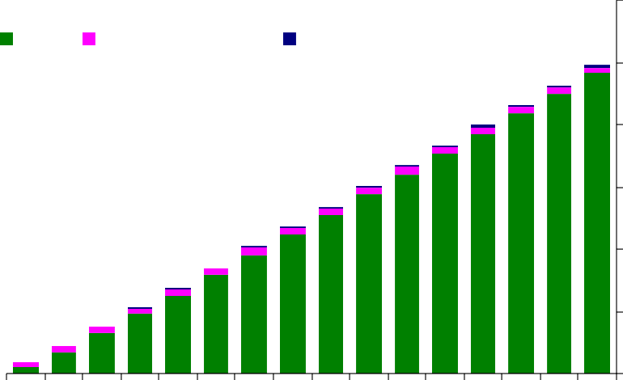

Source: Bank of England

June

May

April

March

100

80

60

40

20

0

**Gilts Commercial paper Corporate Bonds**

£bns

120

Chart 1: Asset Purchase Facility: Weekly Stock Holdings

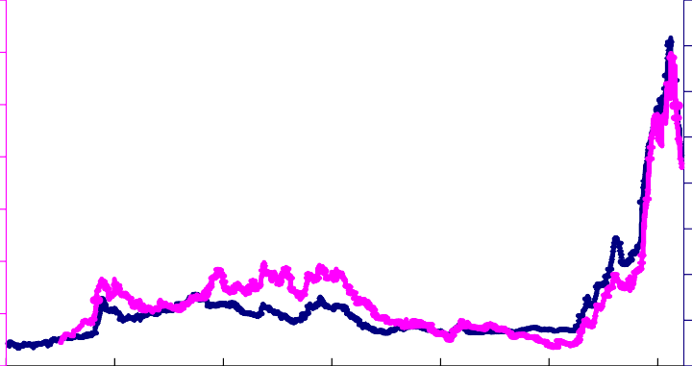

2009

2007

2005

2003

2001

1999

800

700

600

500

400

300

200

100

0

3500

3000

2500

2000

1500

1000

500

0

1997

**Sterling sub-investment grade**

**Sterling investment grade**

Chart 2: UK Corporate Bond Spreads

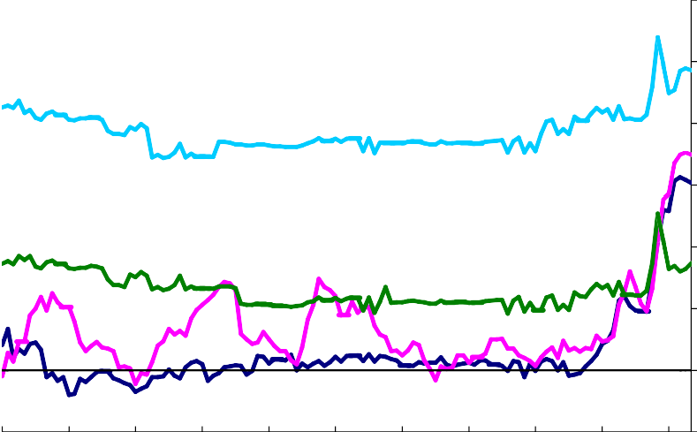

1999 2000 2001 2002 2003 2004 2005 2006 2007 2008 2009

Source: Bank of England

-1

Household 2-Year Discounted Rate (75% LTV)

1

0

PNFC Low Loan Rate

3

2

Household 2-Year Fixed Rate (75% LTV)

4

PNFC High Loan Rate

Percentage Points

6

5

Chart 3: Interest Rate Spreads for Households and PNFCs

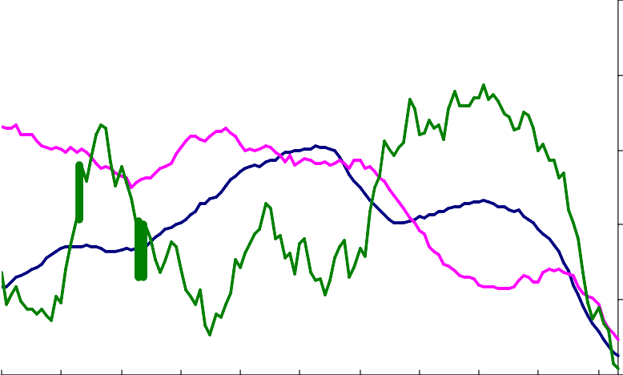

Source: Bank of England

2009

0

Secured lending to individuals

1999 2000 2001 2002 2003 2004 2005 2006 2007 2008

5

10

15

Unsecured lending to Individuals

20

PNFCs M4L

% change oya

25

Chart 4: Growth Rates in Quantities of Credit



0

1997 1998 1999 2000 2001 2002 2003 2004 2005 2006 2007 2008 2009

Basic Taylor Rule Specification:

1

**Forward looking Taylor Rule (a)**

2

**Backward Looking Taylor Rule**

6

5

4

3

**Bank Rate (quarterly averages)**

8

7

Note: The equilibrium real interest rate (rt) is based on the index-linked gilt curve adjusted upwards by 0.5pp to reflect differences between CPI and RPI inflation due to methods of price aggregation. Potential output (y*) is estimated by a hp-filter of output (1970-2007) and subsequently has been increased/decreased at half the growth rate of observed/forecast output. Weightings of 0.5 on output and inflation gap measures follow Taylor (1993).

(a) Forward looking measure advances output gap by 4 quarters and the inflation gap term by 8 quarters.

Per Cent

Chart 5: Interest Rate Implied by Simple Taylor Rule

*it*  * t* 1  0.5( *y*  *y*\*) / *y*\*)*t* 1  0.5(**  ** *)*t* 1  *rt*